|  |  |
| --- | --- |
|  | **ASSIGNMENT TOP SHEET**  **Higher Diploma in Information Technology** |

|  |  |  |  |
| --- | --- | --- | --- |
| Student Registration Numbers | Student Name | | |
| SA 24610429 SA 24610587 SA 24610310 SA 24610325 SA 24610615 | H. N. Manith Dulnim P. K. A. P. Pussewala M.A.M. Aafiq N. Thinesh W.S.DeHoedt | | |
| Group | PC number | | |
| 05 | NA | | |
|  |  | | |
| Module Title : Emerging Technologies and Frameworks | | | Module Code: IT204 |
| Lecturer in charge : Charunika Dampalessa | | | |
| Assignment Title : Class Task 02 – New trends in technologies | | | |
| Due Date: 05.03.2025 | | Date Submitted: 04.03.2025 | |
| Please Tick here if you have used a proof-reader for this assessment : MS Office dictionary | | | |
| Turnitin Paper ID* ---- | | | |

*Not required if not submitting via Turnitin

|  |  |
| --- | --- |
| **Declaration** | |
| I declare that work presented in the assignment submitted to the Sri Lanka Institute of Information Technology is a record of an original work done by myself*.* This assessment is submitted in the partial fulfilment of the requirement for the award of the degree of Bachelor of Science in Information Technology. The results embodied in this report have not been submitted to any other University or Institution for the award of any degree or diploma. Information derived from the published or unpublished work of others has been acknowledged in the text and a list of references is given. | |
| *Name(s) and Signature(s) :*  H. N. Manith Dulnim (Team Leader) | *Date:*  16.02.2025 |

**3  
11  
14  
16  
18**

**Content**

1. **Cloud computing …………………………**
2. **Artificial intelligence (AI) …………………….**
3. **Blockchain …………………………………….**
4. **3D and 4D printing ……………………………**
5. **References …………………………………….**

**Cloud Computing.**

**What is Cloud Computing?**

Cloud computing is the on-demand delivery of IT resources over the Internet with pay-as-you-go pricing. Instead of buying, owning, and maintaining physical data centers and servers, you can access technology services, such as computing power, storage, and databases, on an as-needed basis from a cloud provider.

**Key features of Cloud Computing**

1. On-demand access
2. Scalability
3. Pay-as-you-go model

**Problem Analysis.**

|  |  |
| --- | --- |
| Problem | Cloud Solution |
| Single server setup | Load Balancing |
| Performance Issues | Scalable Infrastructure |
| Frequent Timeouts | Hight Availability |

**What is AWS?**

AWS is known as Amazon Web Services. AWS is a leading cloud service provider, offering over 200 fully featured services from data centers globally. Millions of customers-including the fastest growing startups, largest enterprises, and leading government agencies are using AWS to lower costs, become more agile, and innovate faster.

**Key Features :-**

* Extensive Service Offerings
  + AWS offers over 200 fully featured services from data centers globally. These services span various categories, including computing, storage databases, machine learning, artificial intelligence, data lakes, analytics, and the internet of things. This extensive range of services makes it easier and more cost-effective to move existing applications to the cloud and build new ones.
* Security and Compliance
  + AWS is designed to be the most flexible and secure cloud computing environment available today. It provides over 300 security, compliance certifications. This makes AWS suitable for high-sensitivity organizations such as the military and global banks.
* Innovation and Agility
  + AWS continually accelerates its pace of innovation, enabling businesses to experiment and innovate more quickly. For instance, AWS pioneered serverless computing with AWS Lambda, allowing developers to run code without provisioning or managing servers. AWS also offers Amazon SageMaker, a fully managed machine learning service.
* Global Infrastructure
  + AWS hat the most extensive global cloud infrastructure, with multiple regions and availability zones worldwide. This infrastructure ensures high availability and reliability for applications running on AWS.

**Why AWS for LMS?**

* Global presence
  + The AWS cloud spans 114 availability zones within 36 regions, with announced plans for 12 more availability zones.
* Scalable solutions
  + AWS offers over 200 fully featured services from data centers globally.
* Cost efficiency
  + AWS offers a pay-as-you-go approach for pricing for the vast majority of the cloud services.

**Availability Zones in AWS**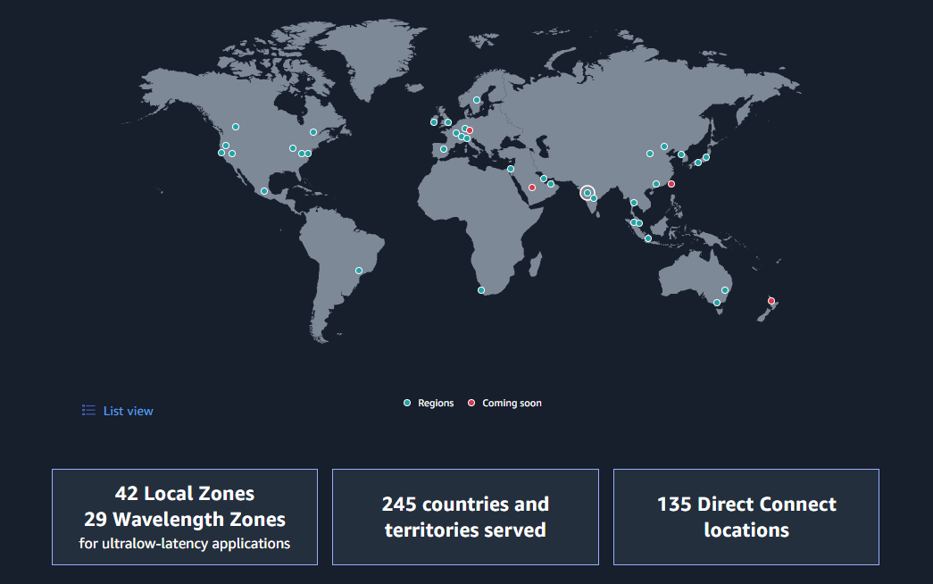

For more details on available zones [click here.](https://aws.amazon.com/about-aws/global-infrastructure/?hp=tile&tile=map)

**AWS Pricing Models.**

AWS introduces several pricing models and also a pricing calculator to calculate the cost. The main pricing models are,

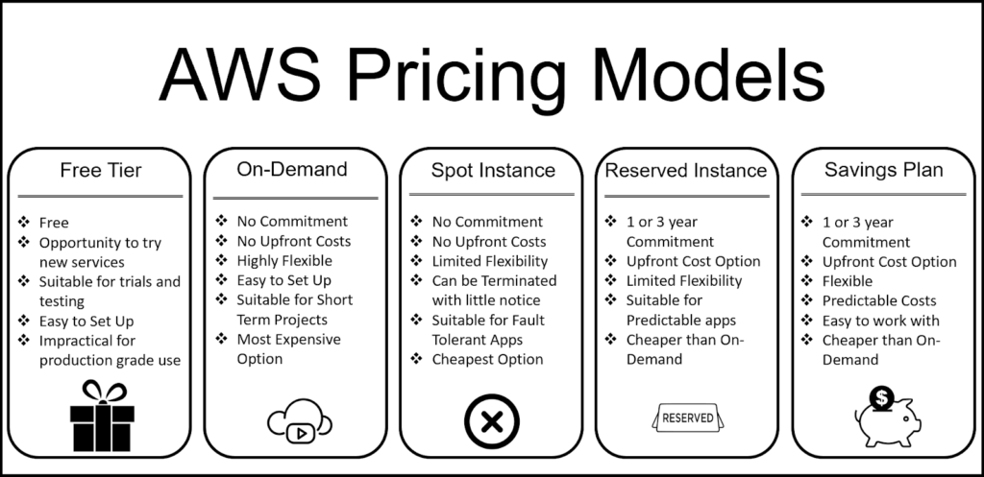

**Recommended pricing model for LMS :-**

* Reserved Instance pricing option

Because of

* Cheaper than on-demand.
* As we can predict our workload it is more suitable.

**AWS EC2(Amazon Web Services Elastic Compute Cloud)**

Amazon Elastic Compute Cloud is a web service that provide resizable computing capacity in the AWS cloud. It allows users to launch virtual servers, known as Instances, on-demand and scale them up or down based on their needs. This flexibility helps reduce hardware costs and accelerates application development and deployment.

**Key features of Amazon EC2**

* Instances
  + EC2 instances are virtual servers that can be configured with different combinations of CPU, memory, storage, and networking capacity. Users can choose from various instance types to match their specific workload requirements.
* AMIs
  + AMIs are pre-configured templates that include the operating system and other software required for your instances. They simplify the process of launching new instances by providing ready-to-use configurations.
* Storage options
  + Amazon EC2 offers multiple storage options, including,
    - Amazon EBS Volumes: Persistent storage volumes that retain data even after the instance is stopped or terminated.
    - Instance Store Volumes: Temporary storage that is deleted when the instance is stopped or terminated.
* Security
  + EC2 provides robust security features such as key pairs for secure login, security groups that act as virtual firewalls, and compliance with Payment Card Industry (PCI) Data Security Standards (DDS).
* Auto Scaling and Monitoring
  + Amazon EC2 integrates with other AWS services like Amazon EC2 Auto Scaling, AWS Backup, Amazon CloudWatch, and Elastic Load Balancing to ensure optimal performance, reliability, and cost-efficiency.

**Why AWS EC2 for LMS?**

* Auto Scaling
  + This service helps to scale the LMS System according to it’s needs. So, you don’t have to worry about server crashing and other problems.
* Load Balancers
  + As AWS EC2 provides the Instances with Elastic Load Balancer(ELB) this helps to evenly distribute traffic among multiple instances. This in turn prevents overloading a single server.

**Deployment Models in Cloud Computing.**

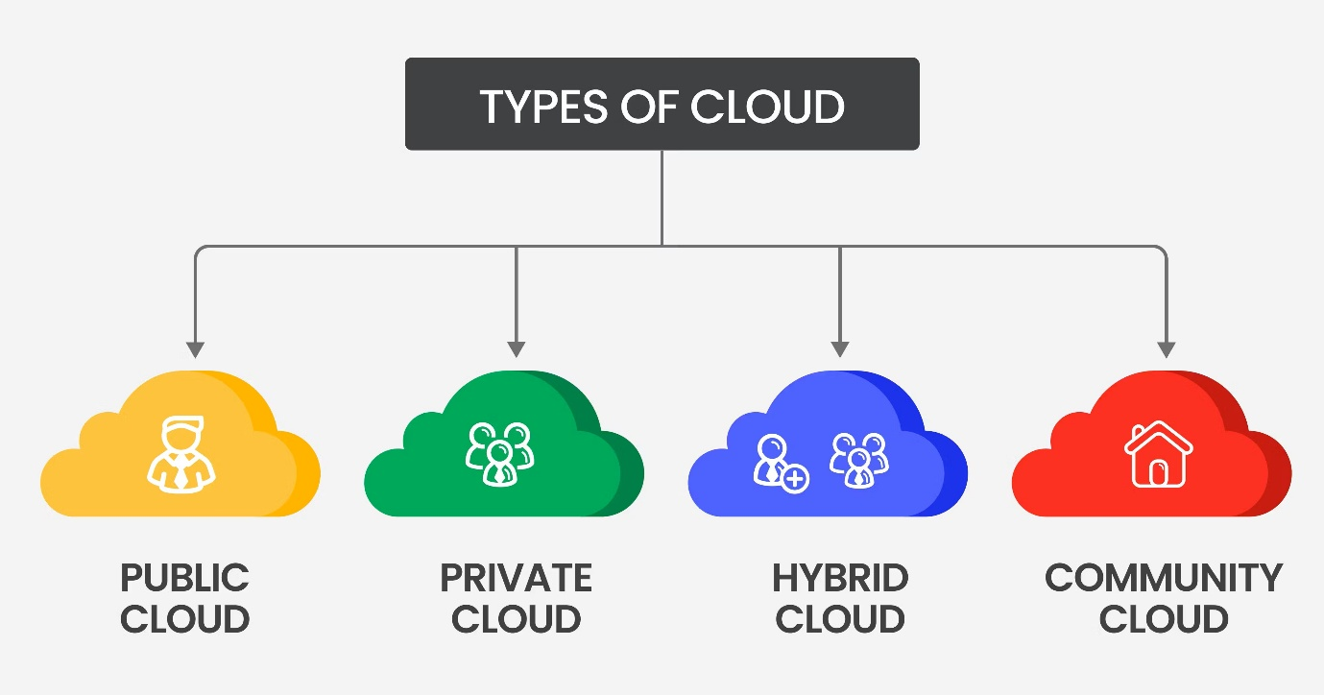There are 4 main deployment models in cloud computing.

1. Public Cloud:
   * Public cloud is accessible to the general public and is owned by a cloud service provider. It offers minimal investment, no setup cost, and no infrastructure management, making it ideal for business needing quick access to resources. However, it is less secure and offers low customization.
2. Private Cloud:
   * The private cloud is dedicated to a single organization, providing better control, data security, and privacy. It supports legacy systems and allows customization. It is also using on-premises severs and other devices to make the infrastructure of the cloud and the network. However, it is less scalable and more costly.
3. Hybrid Cloud:
   * Hybrid cloud is the combination of Public cloud and Private cloud. Offering flexibility, control, and cost savings. It allows organizations to move data and applications between different clouds based on their needs. However, it is complex to manage and may have slow data transmissions.
4. Multi Cloud:
   * The multi-cloud model is usually used by very large enterprises. This model uses multiple cloud providers such as Microsoft Azure, Amazon Web Services, etc. to increase the flexibility and fault tolerance. It allows mixing and matching the best features of each provider but is complex to manage and may have security issues.

**Why Hybrid Cloud for LMS?**

1. Leverages Existing Infrastructure
   * The organization already has and on-premise server, so a hybrid model allows to gradually migrate workloads to the cloud without discarding existing resources.
2. Handles High Traffic Efficiently
   * During the peak times, cloud resources(AWS EC2 Instances) can handle the additional load while the on-premise server manages baseline operations.
3. Cost-Effective
   * Instead of moving everything to the cloud which can be expensive, the hybrid model balances costs by keeping some workloads on-premise while scaling only when necessary
4. Improved Redundancy & Disaster Recovery
   * On-premise + cloud integration ensures high availability, reducing the risk of server downtime.
5. Better Compliance & Security
   * Sensitive data can remain on-premise while utilizing cloud services for scalability and remote access.

**Service Models in Cloud Computing**

There are mainly 3 service models in cloud computing.

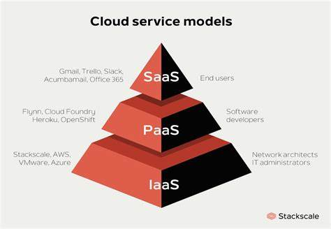

1. IaaS(Infrastructure as a Service)
   * IaaS is a service model that delivers computer infrastructure on an outsourced basis to support various operations. Typically, IaaS is a service where infrastructure is provided as outsourcing to enterprises such as networking equipment, devices, database, and web servers. So, these services usually used by network architectures, IT administrators.
2. PaaS (Platform as a Service)
   * PaaS is a category of cloud computing that provides a platform and environment to allow developers to build applications and services over the internet. PaaS services are hosted in the cloud and accessed by users simply via their web browser. A PaaS provider hosts the hardware and software on its own infrastructure. So, this is usually used by developers.
3. SaaS (Software as a Service)
   * SaaS is a way of delivering services and applications over the internet. Instead of installing and maintaining software, we simply access it via the internet. SaaS provides a complete software solution that you purchase on a pay-as-you-go basis from a cloud service provider. Most SaaS applications can be run directly from a web browser without downloads or installations required.

**Why SaaS for LMS?**

1. No infrastructure management
2. Accessibility & Convenience
3. Scalability for High Traffic Loads
4. Cost-Effectiveness
5. Security & Automatic Updates
6. Quick Deployment

**Challenges of Cloud Computing**

Main challenge of cloud computing is **Privacy and Data Security** because of, the users store data on a third-party cloud. We can’t guaranty the data will not be accessible to another party. So, this is the main concern of cloud computing.

And also cloud computing has other challenges like,

* Compliance & Regulations issues.
* Cost Management issues.
* Data migration issues.

**Conclusion**

Although cloud computing has above risks, still it is the best solution for the current problem in the LMS. Cloud computing makes the LMS more efficient, fast, and more secure.

**Artificial Intelligence**

**Introduction to AI**

The field of Artificial Intelligence (AI) in computer science allows machines to accomplish intellectual work which humans normally handle. AI systems perform features that involve problem-solving as well as decision-making tasks together with natural language processing capabilities and pattern recognition functions. Computers using artificial intelligence systems operate through data learning which lets them adapt to fresh inputs and execute tasks with high speed and precision.

**History of AI**

* Alan Turing established machine intelligence during the 1950s–1960s while the Logic Theorist became one of the first AI programs of this period.
* AI research experienced financial setback during the 1970s and 1980s known as AI winters because computers during this period struggled to meet unrealistic goals.
* The 1990s through 2000s marked a major period of AI advancement while machine learning and expert systems along with neural networks emerged as dominant technologies.
* AI research during the 2010s until the present era has produced practical applications that brought innovation to healthcare services as well as finance operations and e-commerce markets.

**Modern AI**

In the current society, AI has fa ced great transformation in its functionality and it is used almost in all sectors. Current types of artificial intelligence are machine learning, deep learning, NLP, and computer vision. AI is now used for activities that were earlier beyond its realm such as diagnosis of diseases, identification of fraud and for recommending necessary products to people. ChatGPT for example, uses neural networks to comprehend and create text almost analogous to humans, thus making the use of AI easier and faster than before.

**Future of AI**

AI has great potential and will most certainly evolve in the following manners in the future.

* Healthcare: Diagnosis through the use of AI and robotic surgeries will enhance the quality of the health facilities.
* Transportation: The development of self-driving cars and auto industries will be run by AI.
* High security: AI will improve the security measures that protect computers and related systems from hackers and other threats.
* Ethical Attributes of AI: Attempt will be made towards making the AI technology ethical, honest and non-discriminatory.

**Healthcare**

1. **Medical imaging:** AI accurately analyzes X-rays and CT scans, improving diagnosis speed and accuracy for diseases like pneumonia and tuberculosis. It aids in detecting lung nodules, reducing the risk of missing cancerous growths, and identifies osteoporosis in X-rays.

* **EHR analysis:** AI analyzes EHR data to identify patterns and trends, predict disease risks and enable personalized prevention strategies. It examines medical history, lifestyle, and genetic information to forecast risks such as diabetes or heart disease and identifies patterns in medication data to prevent adverse drug reactions.
* **Remote patient care:** AI-powered remote patient care delivers healthcare services regardless of location. Patients receive real-time attention and share health data remotely, and healthcare providers use AI to analyze trends, fostering proactive care. For instance, diabetic patients can continuously monitor glucose levels through wearables, remotely enabling swift adjustments to treatment plans.

**Retail and e-commerce**

1. **Personalized shopping experience:** AI scrutinizes customer behavior, preferences, and purchase history, offering tailored product suggestions based on individualized insights. This enhances the shopping experience, increases customer engagement, and boosts sales by presenting items tailored to individual tastes.

* **Dynamic pricing optimization:** Retailers use AI algorithms to analyze real-time market conditions, competitor pricing, and customer demand. This enables dynamic pricing adjustments, ensuring optimal pricing strategies to remain competitive, maximize profits, and respond to market fluctuations effectively.
* **Inventory management and demand forecasting:** AI helps retailers optimize inventory levels by predicting demand patterns, seasonal fluctuations, and trends. This minimizes overstock and stockouts, reducing holding costs and improving overall supply chain efficiency. By accurately forecasting demand, retailers can ensure product availability and meet customer expectations.

**Banking and financial services**

* Fraud detection and prevention: AI is utilized in banking and finance for fraud detection by analyzing transaction patterns, identifying anomalies, and flagging potentially fraudulent activities. Machine learning algorithms adapt to evolving fraud patterns, enhancing the security of financial transactions.
* Credit scoring and risk assessment: Credit scoring powered by AI utilizes alternative data sources and ML algorithms to enhance the accuracy of assessing the creditworthiness of individuals and businesses. This leads to more effective risk-management empowering financial institutions to make well-informed lending decisions.
* Improved customer service: AI-powered chatbots enhance customer service by providing instant responses to queries, assisting with account inquiries, and offering personalized financial advice. This automation streamlines customer interactions, improves satisfaction, and reduces response times.

## **Introduction to blockchain**

Blockchain is a technology that controls the growth of lists that consist of records, which are also known as blocks. These blocks are securely linked together using cryptography. To make sure that the data is kept secure, each block contains a cryptographic hash of the previous block, a time stamp, and the transaction data which forms into information. Blockchain structures are difficult to hack, change, or be manipulated once the data is recorded as that structure is made to resist modifications. There is no centralized control for blockchains as the data is control over a network of computers. All blockchains are decentralized systems because all the data is validated and updated by the users on the network, which eliminates the need for one central control.

## **History of blockchains**

The first idea of blockchain technology was thought of by a cryptographer, David Chaum, who proposed the idea of a blockchain-like protocol in the early 1980s. That in turn layed down the foundation for further works in blockchain systems. In the early 1990s, two computer scientists, Stuart Haber and W. Scott Stornetta created a more modern line of blockchain. This included a more secure cryptographical chain of blocks that did not allow timestamp tampering of documents. The algorithm that they had written would eventually become known as “Blockchain”. Later on in 1992, the two scientists with the help of Dave Bayer, incorporated Merkle trees into the design, which improved the efficiency of a single block by allowing multiple document certificates to be collected in that singular block. Eventually leading Merkle trees to becoming a crucial part of blockchain architecture. The trio, under their company , Surety, decided to publish document certificates with their theory in The New York Times to see what would happen. The practical experiment eventually led to proof of them creating tamper-resistant digital records.

As time continued on the idea of blockchains kept growing and the concept of Haber, Stornetta, and Bayer kept evolving. Until 1998, when another computer scientist, Nick Szabo, started to work on the concept “bit gold”. “Bit gold” was never implemented into any system, it did show an important path of decentralized digital currencies. Szabo’s research later became seen as an important part of cryptocurrency systems. His work is also seen as the earliest attempt in trying to incorporate decentralized systems into digital currencies. However, just before 1998 around the same time in 1997, another concept called Hashcash was developed by Adam Back. This development introduced the proof-of-work mechanism. This mechanism allowed for blockchains to run without a central authority. Later on in 2000, more theory concepts were put forward by Stefan Konst. His theories were about security of crypto chains and how to implement those securities. The collective of all these theories from different people over time eventually led to the foundation of what modern blockchains are created upon.

## **Blockchain beyond cryptocurrency**

In the past the blockchain technology was mainly only seen in the cryptocurrency field as it was originally intended for. However, as the future evolved this technology was implemented in many more fields. Industries such as healthcare, real estate, government services to supply chain management, and beyond have all started to implement blockchain technology. Even now in 2025, we can see that the core strengths of blockchain technology are being integrated into different platforms.

The use of blockchain technologies continues to grow as they are monitored by businesses and the potential of the technology is seen. Cost reduction, enhanced security, and making precise operations can all be achieved. The improvement of public services and how transparent they are can also be achieved with blockchains, which is why governments are looking to implement them. Furthermore, this technology will only continue to grow as other technologies are developed, opening space for new innovations and implementations.

On the other hand, there are still issues with blockchains, such as scalability and adapting to very specific requirements. These will be sliced as future technologies are created but as for the current moment, blockchain technologies have grown further than its intended starting point.

## **Future of blockchain technology**

The future of blockchain technology is one that is very bright and has high potential for many uses. The rate of adoption of this technology is very high in major sectors across the globe and will only increase as time moves forward. The creation of the business model BaaS (Blockchain-as-a-Service) is another major advancement that is constantly growing. This allows future companies to plan systems where they can use blockchain systems without the need to create systems of their own. The BaaS also allows for organizations of different status to access blockchain technology.

One major aim for the future of blockchain technology is the creation of interconnected blockchain networks from different sectors. The advantages of this function is that blockchain networks can use each other to cover limitations that each network may have on its own. It also allows for organizations to adapt much more quickly and worry less about the risk of compatibility issues. This can be easily done if the differences between each blockchain system are broken down.

Furthermore, many new startups or smaller end businesses can use the blockchain technologies to create more secure platforms by sharing the technology among them. The possibility of devices that are connected together to be able to share data with each other can also be tested with blockchain technologies.

**3D Printing and 4D printing**

**Introduction to 3D and 4D Printing**

**3D Printing**

3D printing, also known as additive manufacturing, is a revolutionary technology that creates three-dimensional objects by layering material based on a digital model. Unlike traditional manufacturing methods that often involve cutting or molding materials, 3D printing builds objects layer by layer, allowing for intricate designs, rapid prototyping, and custom manufacturing. This technology uses various materials, including plastics, metals, ceramics, and even biological substances, making it adaptable across industries such as healthcare, automotive, aerospace, and fashion. The process typically involves designing a 3D model using CAD software, converting it into an STL file, slicing it into layers using slicing software, and then printing it through a 3D printer using G-code instructions.

**4D Printing**

4D printing builds upon 3D printing technology by adding the element of time. In 4D printing, objects are designed to change their shape, structure, or functionality when exposed to external stimuli such as heat, light, water, or pressure. This is achieved by using smart materials, like shape-memory polymers or hydrogels, which react and transform in predictable ways. The 'fourth dimension' refers to this dynamic ability to self-assemble or adapt after printing, opening new possibilities in fields like biomedicine, construction, and robotics. For example, 4D printing can be used to create self-folding structures, medical implants that adapt to the body’s needs, or responsive clothing that adjusts to environmental conditions.

Both 3D and 4D printing technologies are driving innovation by pushing the boundaries of design, functionality, and sustainability, paving the way for smarter and more efficient solutions in various sectors.

The steps of **3D printing** generally follow this process:

1. **Design the 3D Model:**

Create a digital 3D model using CAD software like Blender, Tinkercad, or Fusion 360.

1. **Convert to STL File:**

Export the model to an **STL** (Standard Tessellation Language) file — the most common format for 3D printing.

1. **Slicing the Model:**

Use slicing software (like Cura or Prusa Slicer) to slice the STL file into layers and generate **G-code** (**.gcode** extension). This file contains instructions for the printer on how to build each layer.

1. **Printer Setup:**

Prepare the 3D printer by loading the filament (plastic, resin, etc.) and calibrating the build platform.

1. **Printing:**  
   Upload the **.gcode** file to the printer (via USB, SD card, or Wi-Fi), and start the print. The printer follows the G-code instructions to build the object layer by layer.
2. **Post-Processing:**  
   Once printed, remove the object carefully. Depending on the material, you might need to clean, sand, or cure (for resin prints) the model.

**References**

**Blockchain References**

[1] M. K. Pratt, “What is blockchain and how does it work?,” SearchCIO, Oct. 2023. Available: <https://www.techtarget.com/searchcio/definition/blockchain>  
  
[2] Zerocap, “The Origins of Blockchain Tech,” Zerocap, Feb. 27, 2024. Available: [The Origins of Blockchain Tech - Zerocap](https://zerocap.com/insights/snippets/origins-blockchain-technology/)  
  
[3] S. AshCroft, “Timeline: Evolution of blockchain tech in supply chain,” supplychaindigital.com, Oct. 14, 2022. Available: <https://supplychaindigital.com/digital-supply-chain/timeline-evolution-of-blockchain-tech-in-supply-chain>  
  
[4] “Blockchain Beyond Crypto: How It’s Disrupting Business Models,” Mastersunion.org, 2025. Available: <https://mastersunion.org/blog/blockchain-beyond-crypto-how-its-disrupting-business-models>  
  
[5] “What is the Future of Blockchain Technology - Intellipaat,” Intellipaat Blog, Nov. 19, 2020. Available: https://intellipaat.com/blog/future-of-blockchain-technology/  
  
[6] Rapid Innovation, “AI, Blockchain Solutions & Web3 Development Company,” Rapidinnovation.io, 2024. Available: https://www.rapidinnovation.io/post/blockchain-interoperability-bridging-diverse-networks-for-seamless-integration-2024

**Artificial Intelligence References**

[7] S. Russell and P. Norvig, "Artificial Intelligence: A Modern Approach," 4th ed. Pearson, 2020.  
  
[8] M. A. Gibson, "The Future of AI in Healthcare," HealthTech Journal, vol. 12, no. 3, pp. 45-50, 2024.  
  
[9] N. Smith, "AI and Machine Learning: Transforming Industries," AIResearch, vol. 15, no. 4, pp. 78-89, 2023.  
  
[10] T. Williams, "AI Ethics and Future Challenges," Journal of AI Ethics, vol. 5, no. 2, pp. 34-47, 2024.

**Cloud Computing References**

[11] J. Brown, "Cloud Computing: Concepts, Technology & Architecture," 2nd ed. Pearson, 2023.  
  
  
[12] K. R. Patel, "Cloud-Based Solutions for Modern Businesses," CloudComputingWorld, Apr. 2024. Available: <https://cloudcomputingworld.com/articles/cloud-solutions>  
  
[13] R. Kumar, "Security Challenges in Cloud Computing," Journal of Cloud Security, vol. 9, no. 1, pp. 22-35, 2023.  
  
[14] L. Green, "Multi-Cloud Strategies for Enterprises," CloudBusiness Insights, June 2024. Available: <https://cloudbusinessinsights.com/articles/multi-cloud-strategies>  
  
[15] A. Carter, "Serverless Computing and Its Impact," TechTrends, vol. 8, no. 3, pp. 66-74, 2024.  
  
[16] J. White, "Edge Computing vs Cloud Computing: A Comparative Analysis," Computing Innovations, vol. 11, no. 2, pp. 99-110, 2023.  
  
[17] GeeksforGeeks, “A computer science portal for geeks,” GeeksforGeeks. Available: <https://www.geeksforgeeks.org/>  
  
[18] IBM, “IBM - United States,” IBM. Available: <https://www.ibm.com/>  
  
[19] Amazon Web Services, “Cloud computing services,” AWS. Available: <https://aws.amazon.com/>

**3D and 4D Printing References**

[20] L. Johnson, "The Evolution of 3D and 4D Printing Technologies," AdditiveManufacturingToday, Feb. 2024. Available: <https://additivemanufacturingtoday.com/articles/3d-4d-printing-evolution>  
  
[21] R. Zhang, "Smart Materials and 4D Printing," Journal of Advanced Materials, vol. 18, no. 2, pp. 112-118, 2023.  
  
[22] P. Thomas, "3D Printing in Healthcare: A Revolution in Medicine," MedicalTech Journal, vol. 10, no. 5, pp. 77-89, 2024.  
  
[23] S. Roberts, "The Impact of 4D Printing on Construction and Architecture," SmartConstruction Review, vol. 7, no. 4, pp. 50-62, 2023.  
  
[24] H. Kim, "Bioprinting and the Future of Regenerative Medicine," Journal of Biotech Advancements, vol. 14, no. 3, pp. 101-113, 2024.